1. Rating
Rating in our system is a relationship not entity. The rating happens between user and course. The rate can be described as numbers of stars. And the numbers of stars represent the user’s satisfaction to this course. Meanwhile, the user can also write his description of feeling.
For example, a student thinks this course is hard to understand and the professor performs badly, he is very angry to this course. So he gives this course one star, and he writes some words to describe his feeling. If a student thinks the course is just okay, maybe he will give it three stars and if someone likes it very much, he can give the course full of five stars in our system.
In our system, different kinds of user can both rate the course from his perspective.
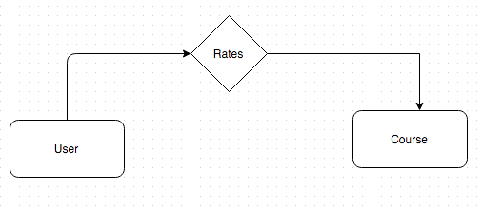
figure 1

2. Browsing
Browsing function in our system is neither entity nor relationship. We achieve it by traverse the database. In our system, what user can browse are courses, course records, institutions, professors, schedules and rates in figure 2.
For example, if a user is browsing the system. He can see what course do we have, the course’s supplier and professor, the course’s schedule and how people rate this course or some other information.
For registered users: Registered user has the same authority with user.
For institution: Besides what user can do, institution can also browse details of the courses taught by its professors, but it has no authority to see the other professors’ courses’ record details.
For example, it can browse the course records of what its professors teach, to see the situation of course registration.
For professor: Besides what user can do, professor can also browse details of this professor’s courses. He has no authority to see the other courses’ record details.
For example, it can browse the course records of what he teaches, to see the situation of course registration.
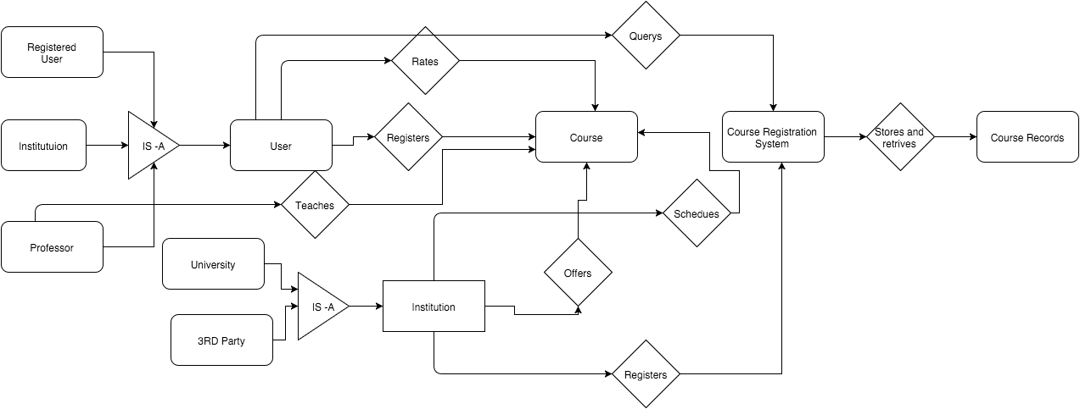
figure 2

3. Searching
Searching function in our system is neither entity nor relationship. We achieve it by search the database. In our system, user can search course, course records, institutions, professors, schedules and rates in figure 2, and user can search by many methods.
For example, if a user is searching the system. He can search the course by specific name, or he can just search by the category, specific professor, institution, etc. He can also search the rates about a specific kind of courses, to find the better courses.
For registered users: Registered user has the same authority with user.
For institution: Besides what user can do, institution can also search details of the courses taught by its professors, but it has no authority to search the other professors’ courses’ record details.
For professor: Besides what user can do, professor can also search details of this professor’s courses. He has no authority to search the other courses’ record details.

4. Bidding
Bidding in our system is neither entity nor relationship. The bidding happens between user and course, we can finish it in the register relation.
Normally, the professor’s energy is limited, as a teacher he needs to grade students’ homework and answer students’ question. So sometimes the course can be bid as a selling item. To this kind of courses, we need the bidding function.
We achieve it in the register relation. Everyone who wants to attend this course will give his bid, and the system records it. After this, if the course has n seats, we choose the higher n registered users to register.
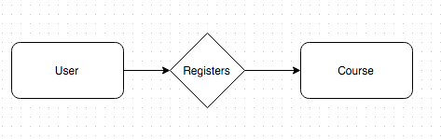
figure 3

